Docker containers login command ,
Container login --------------sudo docker exec -it docker-frontend-1 /bin/sh

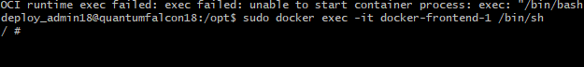
Check container inside memory,
cat /sys/fs/cgroup/memory.max

1073741824 bytes ÷ 1024 ÷ 1024 ÷ 1024 = 1 GB
Identity ;
sudo docker exec -it docker-idntity-1 bash
cat /sys/fs/cgroup/memory.max
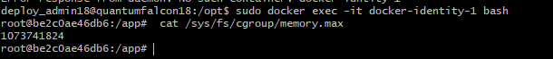

Invoice ;
sudo docker exec -it docker-invoice-1 bash
cat /sys/fs/cgroup/memory.max

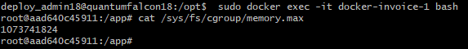

Employee ;
sudo docker exec -it docker-employee-1 bash
cat /sys/fs/cgroup/memory.max


Where I can add memory to container,
Each container we can add memory in docker compuse file just one line add gm,
Example ;

services:
frontend:
build:
context: ../
dockerfile: docker/frontend
image: frontend-demo
ports:
- "80:80"
- "443:443"
networks:
- ems-demo-docker-network
environment:
- ELASTICSEARCH_URL=http://host.docker.internal:9201
- SPRING_DATASOURCE_URL=jdbc:mysql://192.168.1.164:3306/invoice
volumes:
- /etc/letsencrypt/live/ems.pathbreakertech.in/fullchain.pem:/etc/ssl/certs/server.crt:ro
- /etc/letsencrypt/live/ems.pathbreakertech.in/privkey.pem:/etc/ssl/private/server.key:ro
- /etc/letsencrypt/ssl-dhparams.pem:/etc/ssl/dhparam.pem:ro
- ems_produpload_files:/home/deploy_admin18/ems_prod_imag_bkp/
mem_limit: 1g

identity:
build:
context: ../
dockerfile: docker/identity
image: identity-demo
ports:
- "9002:9002"
networks:
- ems-demo-docker-network
environment:
- ELASTICSEARCH_URL=http://host.docker.internal:9201
- SPRING_DATASOURCE_URL=jdbc:mysql://192.168.1.164:3306/invoice
volumes:
- ems_produpload_files:/home/deploy_admin18/ems_prod_imag_bkp/
mem_limit: 1g

employee:
build:
context: ../
dockerfile: docker/employee
image: employee-demo
ports:
- "8012:8012"
networks:
- ems-demo-docker-network
environment:
- ELASTICSEARCH_URL=http://host.docker.internal:9201
- SPRING_DATASOURCE_URL=jdbc:mysql://192.168.1.164:3306/invoice
volumes:
- ems_produpload_files:/home/deploy_admin18/ems_prod_imag_bkp/
mem_limit: 1g

invoice:
build:
context: ../
dockerfile: docker/invoice
image: invoice-demo
ports:
- "8002:8002"
networks:
- ems-demo-docker-network
environment:
- ELASTICSEARCH_URL=http://host.docker.internal:9201
- SPRING_DATASOURCE_URL=jdbc:mysql://192.168.1.164:3306/invoice
volumes:
- ems_produpload_files:/home/deploy_admin18/ems_prod_imag_bkp/
mem_limit: 1g

networks:
ems-demo-docker-network:

volumes:
ems_produpload_files:
=================================================
after adding memory we can start containers like docker compose file up,
sudo docker compose -f docker/DockerCompose.yml up -d –build
==========================

